What’s in a Name? Anthem Word Associations
Character/Place | Definition/Connotation | Significance: Why did Rand choose this word? (How does this add to her message?)
Anthem
Equality
Liberty
Union
International
Palace
Unmentionable (Times)
Collective
Similarity
Fraternity
Solidarity
Unanimity
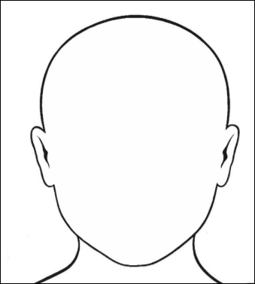
In the mind map, illustrate Equality 7-2521’s goals and interests on the left side. Then, illustrate what he expected to be on the right. Use images as well as quotes from the text

