Name: ______________________________________ Period: _______ Date: __________
Act 5
Macbeth 5.1
- What does Lady Macbeth's sleepwalking demonstrate about how she feels about the murders?

- What does the doctor say Lady Macbeth needs? Use the exact quote.

Macbeth 5.2
- Who leads the English army?

- How do Macbeth’s soldiers feel about him?

Macbeth 5.3
- Explain why Macbeth is still unafraid at this point.

- After the servant tells Macbeth that the English army has arrived, what does Macbeth compare his life to? What does he mean by that?

- What evidence is there in this scene that Macbeth may be going insane as well?

Macbeth 5.4
- How do the English plan to conceal their army? Explain why this plan is important (What prophesy does it fulfill)

Macbeth 5.5
- What signs do you see at the beginning of this scene that Macbeth’s rule is crumbling?

- Describe how Macbeth reacts to the news of his wife’s death.

- In his famous, “Tomorrow, and tomorrow, and tomorrow” speech, name at least three things to which Macbeth compares his life.

- Based upon these comparisons, what do you think Macbeth is trying to say about life through this speech?

Macbeth 5.6
- Explain what we know of Malcom’s battle plan.

Macbeth 5.7
- At the beginning of this scene, to what does Macbeth compare himself? Explain what he means by this comparison.

- Who else dies in this scene?
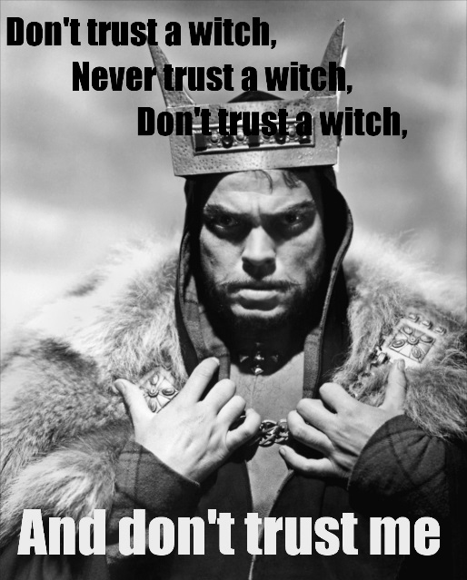
- How is the battle going according to Siward?

Macbeth 5.8
- What does Macduff reveal about his birth?

- What is Macbeth’s final opinion of the witches?

- What does Malcom vow to do at the end of the scene?

After you finish Macbeth, if you think back to the three apparitions which Macbeth saw, the appearance of the apparitions and the messages which they carry for Macbeth will make more sense. For each apparition, list what the apparition looked like, what the message from the apparition was, and then explain how the appearance of the apparition and its message are connected.
First Apparition
- Appearance:

- Message:

- Connection:

Second Apparition:
- Appearance:

- Message:

- Connection:

Third Apparition:
- Appearance:

- Message:

- Connection:

