Name: _______________________________ Period: ________ Date: _________
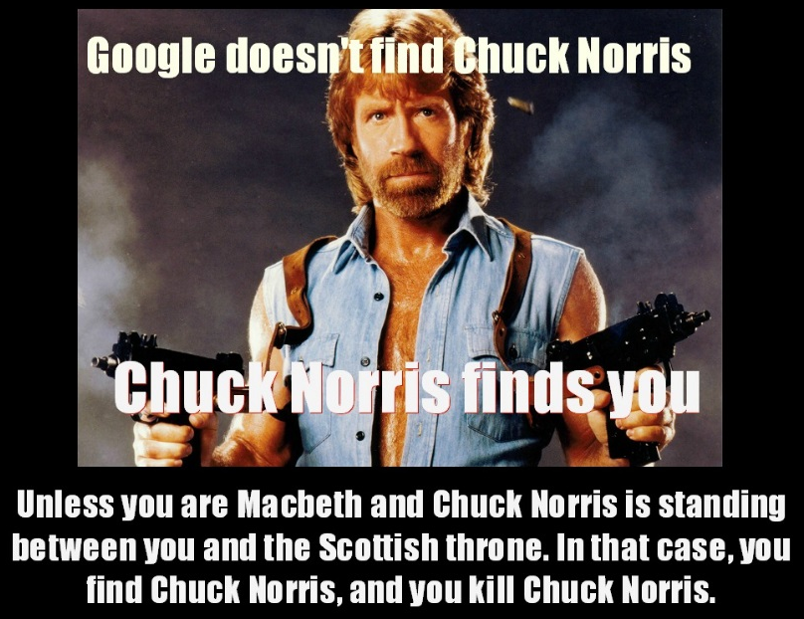
Macbeth 4.3
- Explain why Malcom doesn’t totally trust Macduff in the beginning of this scene. What is Malcom afraid might happen?

- Malcom wants to test Macduff to make sure that Macduff is honest and has his priorities straight. Explain the “test” which Malcom sets up for Macduff.

- Think about the test which Malcom set up for Macduff. How does this test show an important difference between the former King Duncan and Malcom?

- What special powers does King Edward supposedly have?

- Remember that a foil character is a character who strongly contrasts another character. Explain how King Edward is a foil character for Macbeth.

FYI…
(from Elements of Literature p. 505)
The King’s Evil
In Act IV, Scene 3, Malcom and Macduff, exiled from Scotland, discuss the characteristics of a good king and praise King Edward, who has given them political asylum in England. Edward, a saintly monarch known to history as “the Confessor,” was believed to have the gift of healing any of his subjects who suffered from an ailment known as the king’s evil, a kind of scrofula or tuberculosis of the lymphatic glands and primarily a disease of children. Long before Shakespeare’s time, the custom of being touched by the king was abandoned, but King James revived the practice and his successors continued it for a century or so. The eighteenth-century writer Samuel Johnson, scrofulous as a child, was one of the last English people to receive the royal touch.
The conversation between Malcom and Macduff not only compliments King James indirectly, but also implicitly condemns Macbeth, a kingly killer rather than a healer of children. Edward cures evil; Macbeth is evil.

- Describe how Macduff reacts to the news that his family has been killed.

- Whom does he blame for their death (besides Macbeth)?

- What does Macduff swear to do at the end of this scene?

