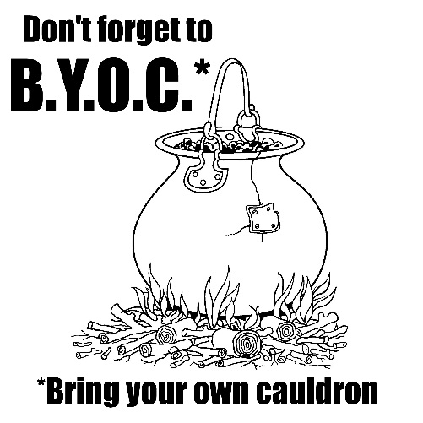
Name: _____________________________________ Period: _____ Date: ________
Macbeth 4.1
- Name something that the first, second, and third witches throw into the cauldron while creating the spell.
  - First witch:

  - Second witch:

  - Third witch:

- Write down the phrase which is repeated several times by the witches:

- What does the above phrase mean? What does it tell you about the purpose of this spell or charm which they are casting?

- At the end of the spell, the second witch says,
“By the pricking of my thumbs,
Something wicked this way comes.”
To whom does this phrase refer? Explain how you know.

- Describe what each apparition (or ghost) looks like and what message the apparition brings for Macbeth.
  - First Apparition:

  - Message from First Apparition:

  - Second Apparition:

  - Message from Second Apparition:

  - Third Apparition:

  - Message from Third Apparition:

- What is Macbeth’s final question for the witches?

- How do the witches answer his final question?

- At the end of the scene, Macbeth finds out that Macduff has gone to where? __________________________
- What does Macbeth plan to do while Macduff is gone?

Macbeth 4.2
- Describe how Lady Macduff feels about the fact that her husband has gone away to England.

- What does Lady Macduff say makes a traitor a traitor?

- Lady Macduff tells her son that Macduff is a traitor. Do you think that Macduff is a traitor? Explain why or why not.

- Evaluate Macduff’s decision to leave Fife and go to England. Was it a good choice or a bad choice? Why?

